INFS 778 Deep Learning Quiz 3: Intro to Convolutional Neural Networks (total 25 points)
Due: 7/7 Sunday Midnight 11:59 PM
- Please complete the 2D convolution shown below (3 points)
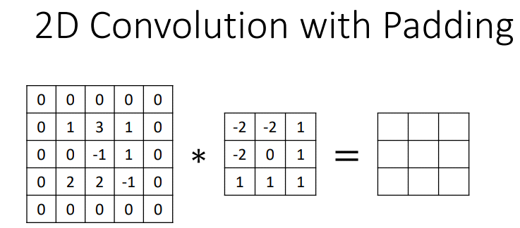
Hint: the value to be calculated:

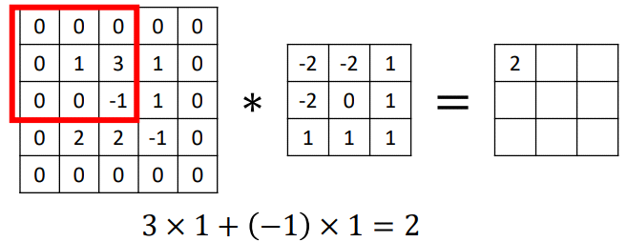

- For the above convolution, what is the stride S? What is the amount of zero padding used P? Please name the three square-shared boxes properly (5 points)

Answer:
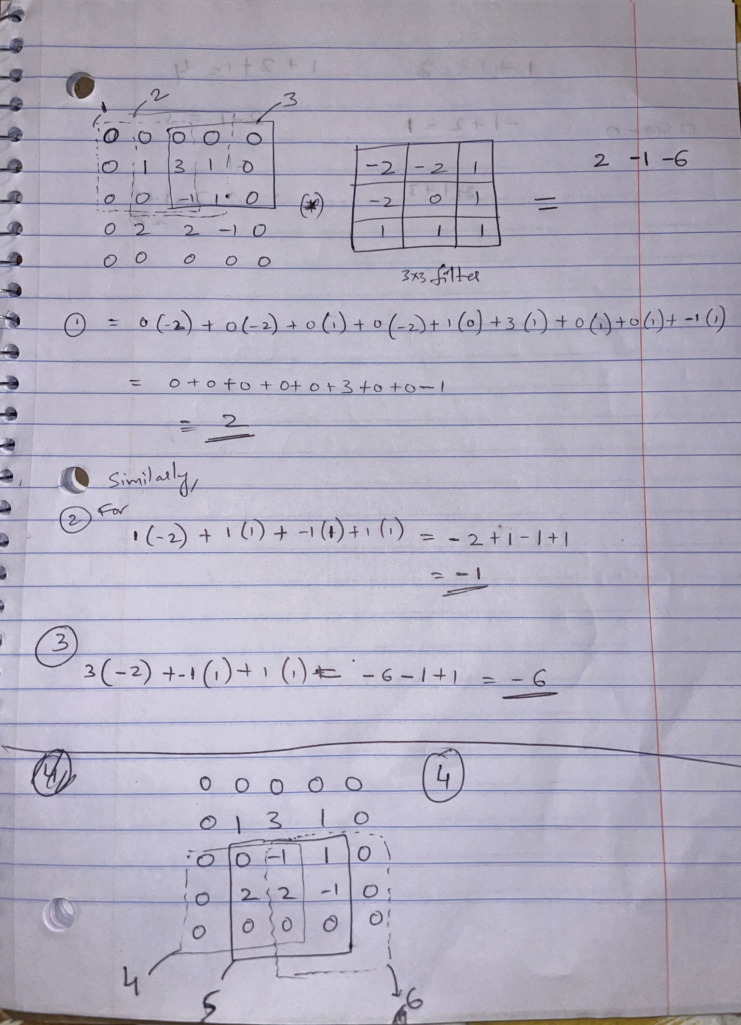
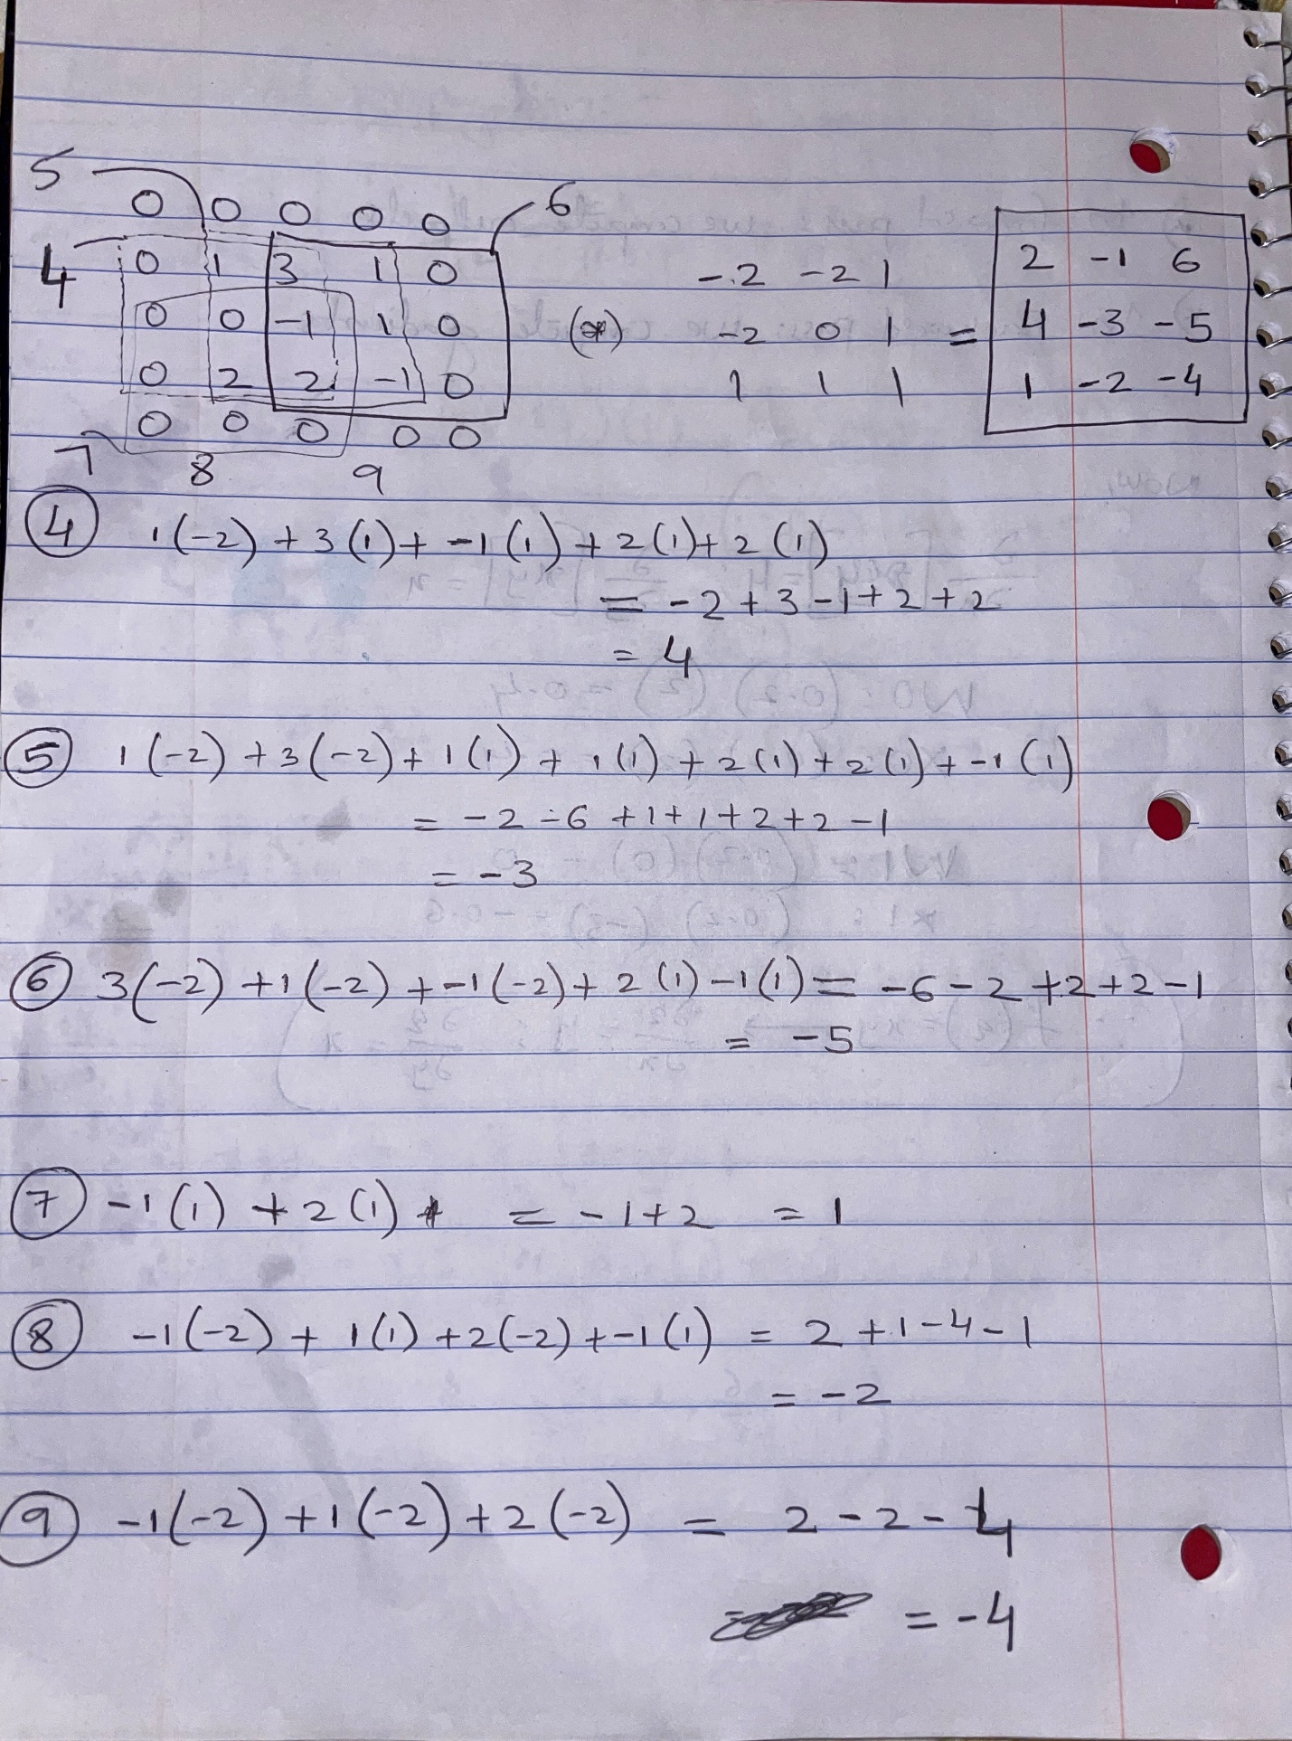

Convolution Details:
Input Matrix (N): 5x5
filter (F): 3x3
Stride S =1
Output size: (N - F) / stride + 1 = (5-3)/1 +1 =2+1 = 3
To find Padding P,
Output size = (N + 2P - F) / stride + 1
3= (5+2P-3)/1 +1
3=2+2P +1
P=0
* Suppose the output matrix size is 5x5, similar to the input size.
Then, Output size = (N + 2P - F) / stride + 1
5= (5+2P-3)/1 +1
3=2+2P +1
P=1
====================================================================================

- Now, consider the demonstration of convolutional operations on: http://cs231n.github.io/convolutional-networks/
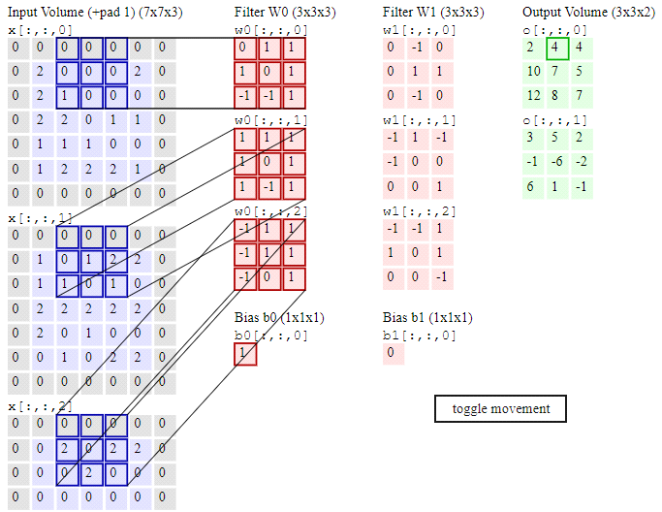
This is a screen shot.

What is the shape of inputs before padding? Shape of filter? Shape of output volume? Total number of parameters (including Ws and bs)? (5 points)
Hint: The stride used here is 2.

Answer:
Shape of Inputs Before Padding:
The input volume before padding has dimensions W1×H1×D1=5×5×3.
After padding of P=1, the input size becomes (5+2)×(5+2)×3=7×7×3.

Shape of Filter:
Each filter has a size of F×F×D1=3×3×3.
Shape of Output Volume: Given the formula for the output dimension in a convolutional layer is (W−F+2P)/S+1, the output dimensions are:
(5−3+2×1)/2+1=3. Since there are
K=2 filters, the output volume is 3×3×2.

Total Number of Parameters (including Ws and Bs):
Each filter has 3×3×3=27 weights, and there are 2 filters, so 27×2=54 weights.
Each filter also has a bias, adding 2 more parameters (one per filter).
Total parameters = 54 weights + 2 biases = 56 parameters.

==============================================================================
- (Total 12 points) Now, consider the classic AlexNet (Krizhevsky et al. 2012) architecture shown below.
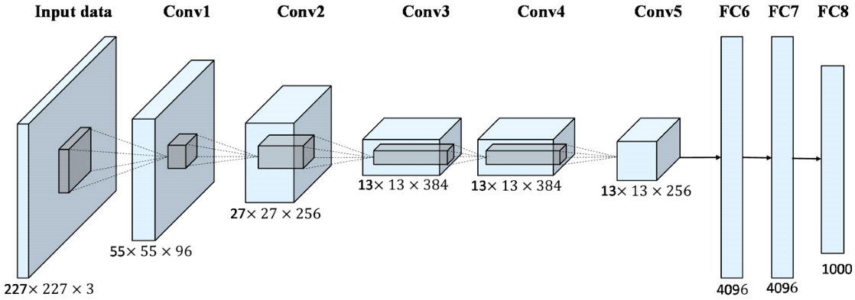
Between Input Data and Conv1, what is the size of receptive field? The number of filters used here? How do you calculate the shape of the output volume as 55X55X96 shown above? (6 points)
Hint: The stride used here is 4 and no zero padding.

Answer:
In the classic AlexNet architecture from the Convolutional Neural Network, we need to compute the receptive field size, the number of filters, and how the output volume shape of 55×55×96 is achieved from the input volume of 227×227×3.

1. Receptive Field Size
The receptive field refers to the region in the input image that each neuron in feature map is looking at.
Given the parameters:
Stride (S): 4 (the distance the filter moves across the input volume)
Kernel or Filter Size (K): It is 11 x 11
For the AlexNet configuration from the first convolutional layer (Conv1), the typical setup uses a kernel
size (K) of 11. This means that each neuron in the output volume covers a 11×11 region of the input image.
Thus, the receptive field size is 11×11.

2. Number of Filters
The number of filters corresponds to the depth of the output volume. For Conv1, as shown in architecture, there are 96 filters. This means that there are 96 unique feature maps being created, each by a different filter scanning over the input image.

3. Output Volume Shape Calculation
The output volume shape can be calculated using the formula for any convolution layer's output dimensions given by:
Output height/width= (Input height/width−Kernel size+2×Padding)/stride +1

For the first convolutional layer:
Input dimension: 227×227×3
Kernel size (K): 11
Stride (S): 4
Padding (P): 0 (no zero padding)
Output dimension= (227−11+2×0)/4 +1= ( 216/4) +1= 54+1=55

Thus, each side (width and height) of the output volume is 55, and with 96 filters, the depth is 96. So, the shape of the output volume is 55×55×96.
======================================================================================

Please compute the total number of trainable parameters between Input Data and Conv1 (show necessary steps of your calculations). What is the total number of parameters if Conv1 is a fully-connected layer? (6 points)
Hint: Comparing the two numbers, you would notice that it is the concept of parameter sharing (to reduce the total number of trainable parameters in ConvNets).

For computing the total number of trainable parameters for the first convolutional layer (Conv1) in AlexNet and compare it with a hypothetical scenario where Conv1 is a fully-connected layer, we will consider the differences in how weights are utilized and shared in convolutional layers versus fully-connected layers.

Parameters in Convolutional Layer (Conv1)
The Conv1 layer uses a set of filters (or kernels), each of which has its own set of weights. The number of parameters is determined by the number of filters and the size of each filter, including its depth, which corresponds to the number of input channels.
Kernel Size: 11x11
Number of Channels in Input: 3 (RGB)
Number of Filters: 96

The formula for calculating parameters in a convolutional layer is
Number of Parameters=Kernel Width× Kernel Height× Input Channels× Number of Filters
Number of Parameters=11×11×3×96=34,848

Parameters if Conv1 Were a Fully Connected Layer
If Conv1 were a fully connected layer instead of a convolutional layer, each input unit would be connected to every output unit. The computation is quite different as there is no parameter sharing:

Input Dimension: 227x227x3 (from the image size and channels)
Output Dimension: 55x55x96 (considering each output neuron in the feature map)

The formula for calculating parameters in a fully-connected layer is
Number of Parameters=Number of Inputs × Number of Outputs
Number of Inputs=227×227×3=154,587
Number of Outputs=55×55×96=290,400

Total Parameters=154,587×290,400 ≈ 44,884,144,800

Comparing the Concept of Parameter Sharing
Convolutional Layer Parameters: 34,848
Fully-Connected Layer Parameters: Approximately 44.9 billion
The difference is immense, illustrating the concept of parameter sharing in convolutional networks. In a CNN, each filter is applied across different parts of the input, using the same weights to detect features anywhere in the image. This drastically reduces the number of parameters, making the network more manageable in terms of computational resources and less prone to overfitting compared to a fully-connected design.
Each neuron in a convolutional layer only needs to learn one set of weights, which are shared across all spatial positions in the input, in contrast to a fully-connected layer where every connection has a unique weight. This efficiency is one of the key advantages of convolutional layers, especially when dealing with large images and deep networks.

====================================================================================================================================================================

